**UNSW Tennis Club – Eastern Suburbs Tennis Competitions**

**Annual Report 2012**

Chris Vik

The University of New South Wales Tennis Club continues to be one of the strongest sporting clubs at UNSW, and 2012 continued to be another successful year for all aspects of the Club’s activities. UNSW Tennis Club continues to organise the ever-popular social tennis, and its own club championships, and also achieved success in the NSW and Australian University Games.

The UNSW Tennis Club continued to utilise its new tennis courts at the David Phillips Sporting Fields on the corner of Banks and Gwea Ave, Daceyville. The four tennis courts are about a 10 minute walk from the main Kensington campus, and are Plexipave hardcourts with lighting for night time play.

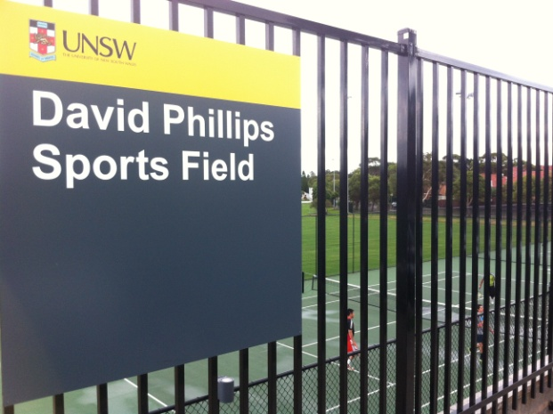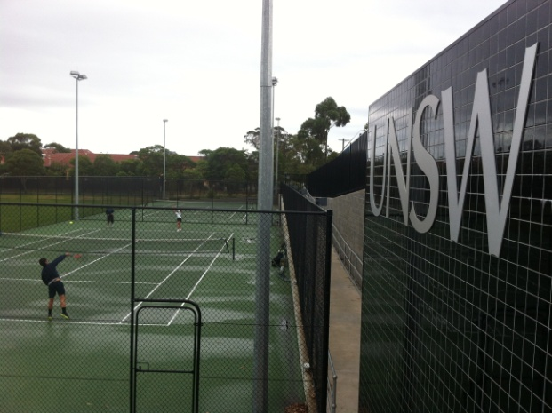

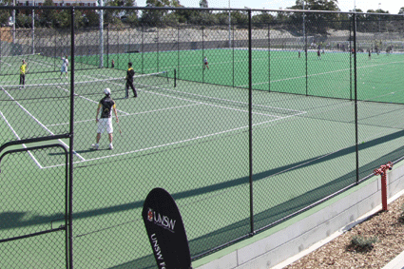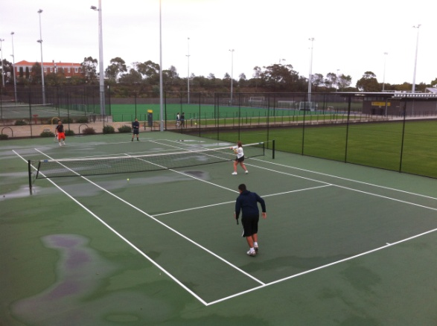

**Eastern Suburbs Tennis Competitions**

2011/2012 was another successful year for the UNSW Tennis Club in the local Eastern Suburbs Tennis Competitions as it continued to be one of the strongest Eastern Suburbs clubs represented in these competitions.

The competitions comprise the Saturday afternoon mixed doubles competition, where UNSW has consistently had 1-2 teams, and the Sunday morning competitions, which are either played from 8am to 10am or 10am to 12noon. The Saturday afternoon competition consists only doubles, whereas the Sunday morning competitions include both singles and doubles. All competitions play for 10 weeks plus finals, and there are 3 equivalent competitions each year.

Most of the UNSW Tennis Club teams in the Eastern Suburbs Tennis Competitions play their home matches at the Snape Park Tennis Centre in Maroubra. There are 6 synthetic grass courts at this complex.

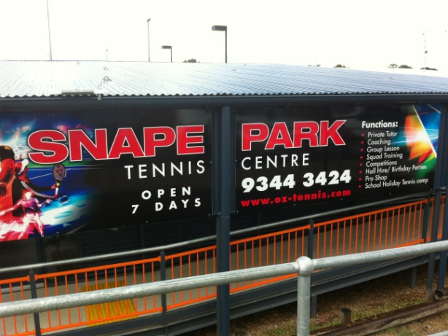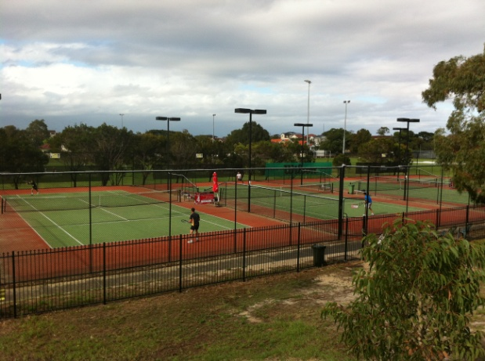  
  
The UNSW Tennis Club also had teams play from the David Phillips Sporting Fields after UNSW Sport & Recreation agreed to provide free court hire to teams playing in the Eastern Suburbs Tennis Competition comprising of all current UNSW students. Unfortunately not many teams comprise of current UNSW students as UNSW teams now comprise of mainly ex-students, staff and other members of the public.

One long-time member of the UNSW Tennis Club who has played in the Eastern Suburbs Tennis Competitions for over two decades is Ian Barnes, and in 2012 he played in the competitions using his home court in Warners Ave, Bondi, as his home court:

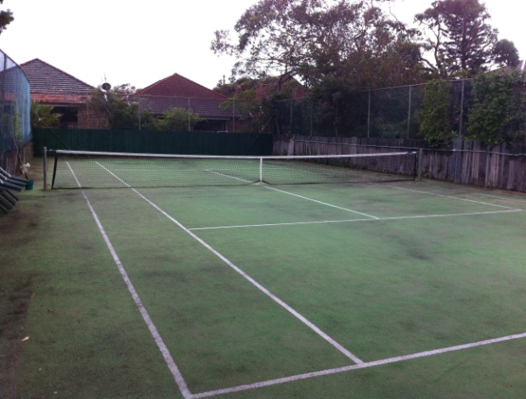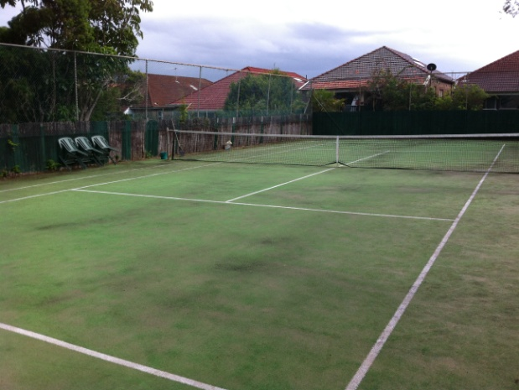

The Summer 2012 competition included 12 UNSW teams, including the only team that played in the Saturday afternoon mixed doubles competition during the year. Three UNSW teams won their respective grades – UNSW SP 1 in A1/1 (Craig Hunt, Peter Elliott, Greg Westwood, Michael Vickery), UNSW SP 5 in A1/2 (Jared Cohen, Noah Cohen, Stephen Cohen, Josh Penn) and UNSW SP 10 in B1/1 (Chelsea Albert, Anil Fernando, Bill (William) Low).

The Winter 2012 competition saw the number of UNSW teams grow to 13, all playing in the Sunday morning competitions. UNSW again won three grades, with UNSW SP 1 (Geoff Daus, Ben Tari, Shane Fawcett) winning A Reserve/1, UNSW SP 7 (Robert Moh, Chris Stanton, Tomas Paterlini) winning A3/2 and UNSW SP 10 (Greg Stewart, Zack Chu, Sam Morse) winning A4/2.

The Spring 2012 competition saw the number of UNSW teams drop back to 12 again, with all teams playing on Sunday morning again. UNSW once again won three grades, which was a great ratio for our teams! UNSW SP 1 (Craig Hunt, Greg Westwood, Ben Tari) won the A1/1 grade, UNSW DP 8 (Robert Moh, Chris Stanton, Tomas Paterlini) won the A2/2 grade, and UNSW SP 11 (Chelsea Albert, Anil Fernando, Bill (William) Low) won the B1/1 grade.

While the number of UNSW teams involved in the Eastern Suburbs Tennis Competitions has fallen from recent years (there were a record 20 teams involved in the Summer 2010 competition), the total number of teams playing in the Eastern Suburbs Tennis Competitions from all centres is the highest in over a decade. While some UNSW players have left to join a more structured tennis club like Maccabi or Jensens, hopefully the ongoing contingency of new UNSW students and the continued popularity of tennis will see UNSW team numbers once again hit record highs.